**PRACTICAL 10 : Storing Real-Time Data in Firebase**

**Aim :** To store real-time sensor data in Firebase using Arduino and NodeMCU. (Optional)

**Overview :**

This project involves interfacing a sensor with Firebase using Arduino and NodeMCU to store real-time sensor data in a cloud database. It introduces IoT cloud computing, real-time database integration and data retrieval for smart applications.

**Materials Required :**

* Arduino Uno R3
* 2 x 1 kΩ Resistor
* Temperature Sensor (TMP36)
* Wifi Module (ESP8266)
* Jumper Wires
* Arduino IDE (Installed on your Computer)

**Circuit Connection and Steps :**

1. **Power Connections :** 
   * TMP36 VCC → 5V (Arduino), GND → GND (Arduino)
   * ESP8266 VCC & CH_PD → 3.3V (Arduino), GND → GND (Arduino)
2. **Sensor & ESP8266 Wiring :**
   * TMP36 VOUT → A0 (Arduino)
   * ESP8266 TX → RX (Arduino) via 1kΩ resistor
   * ESP8266 RX → TX (Arduino) via voltage divider (two 1kΩ resistors)

**Circuit Diagram :**

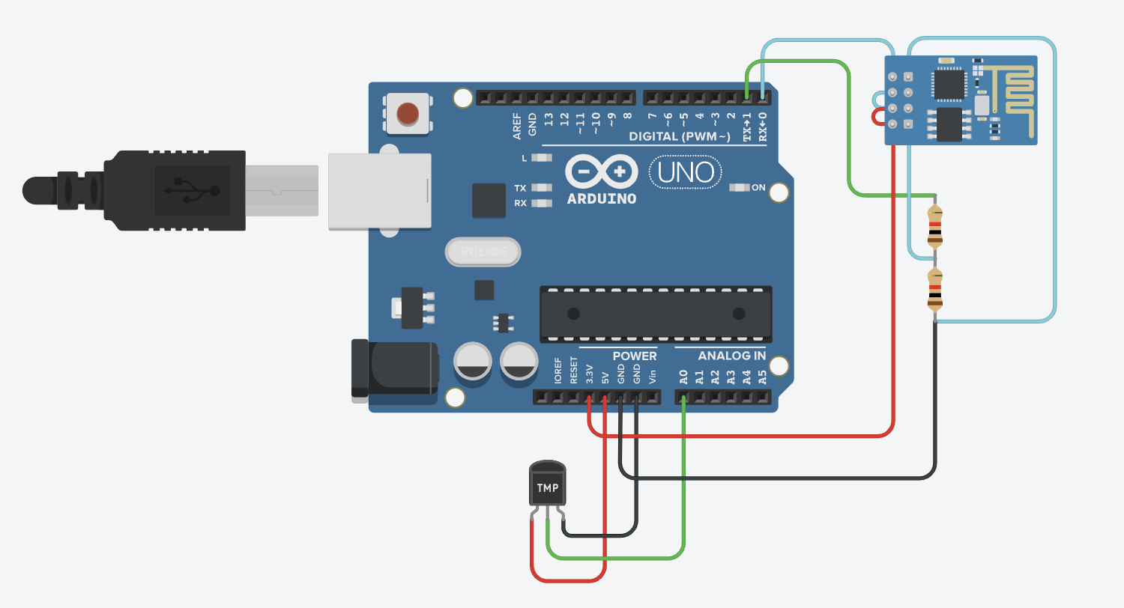

**Schematic Diagram :**

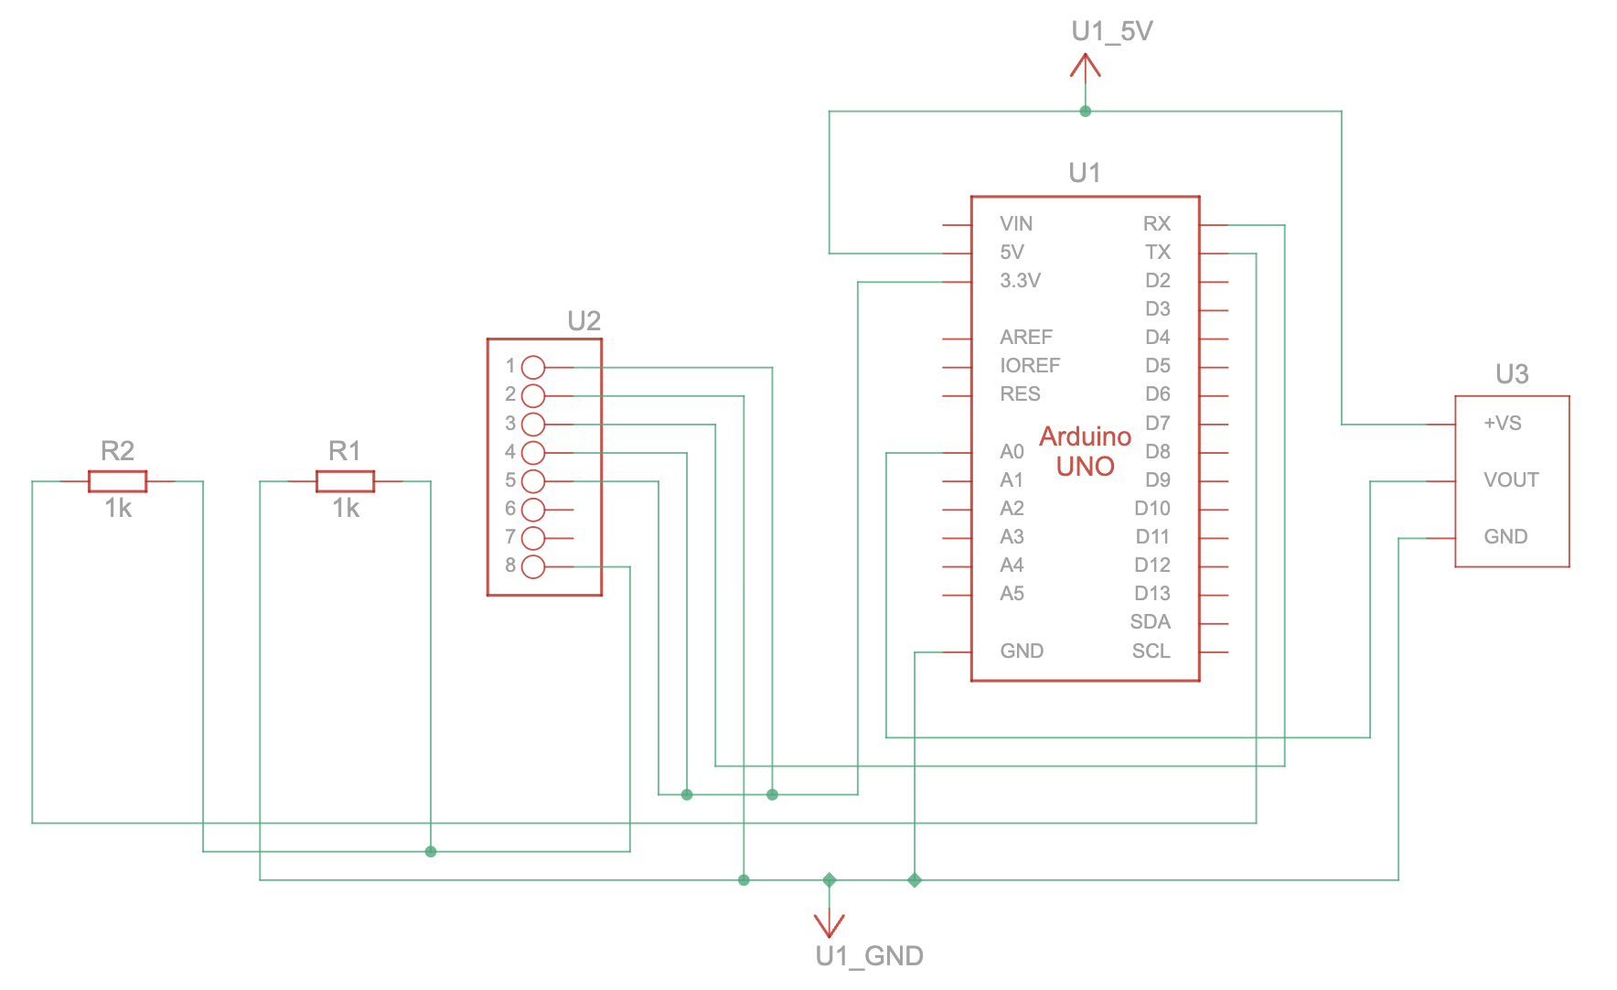

**Code :**

// WiFi Credentials

String ssid = "Simulator Wifi";

String password = "";

// Firebase Configuration

String host = "realtime-database-iot-default-rtdb.asia-southeast1.firebasedatabase.app";

const int httpPort = 80;

String firebasePath = "/Temperature.json"; // Firebase RTDB Path

String firebaseAuth = "uLsBh7JKrBOSQY8IsnmjOrFB58xZ8ZZABLT708Qv";

// Sensor Pin

const int tempPin = A0;

void setup() {

Serial.begin(115200);

Serial.println("AT"); // Check ESP8266 response

delay(500);

// Connect to WiFi using AT commands

Serial.println("AT+CWJAP=\"" + ssid + "\",\"" + password + "\"");

delay(5000);

// Establish TCP Connection with Firebase

Serial.println("AT+CIPSTART=\"TCP\",\"" + host + "\"," + String(httpPort));

delay(500);

}

void loop() {

// Read Temperature Sensor

float temperature = ((analogRead(tempPin) * 0.0048828125) - 0.5) * 100;

// Construct HTTP request for Firebase

String httpRequest = "POST " + firebasePath + "?auth=" + firebaseAuth +

" HTTP/1.1\r\nHost: " + host + "\r\nContent-Type: application/json\r\n" +

"Content-Length: " + String(String(temperature).length() + 14) + "\r\n\r\n" +

"{\"value\": " + String(temperature) + "}";

// Send Data to Firebase

Serial.println("AT+CIPSEND=" + String(httpRequest.length()));

delay(500);

Serial.println(httpRequest);

delay(5000);

}

**Results :**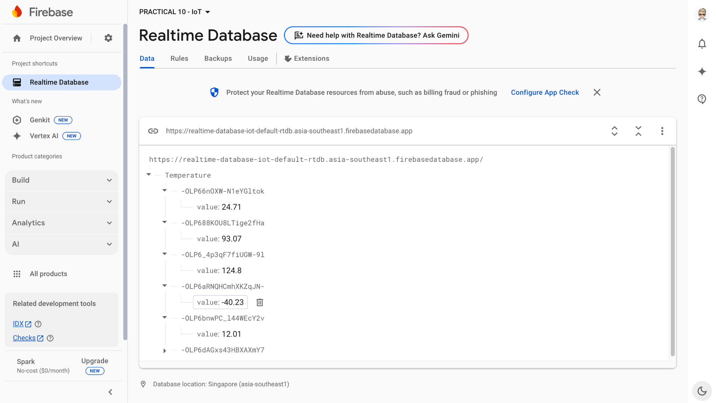

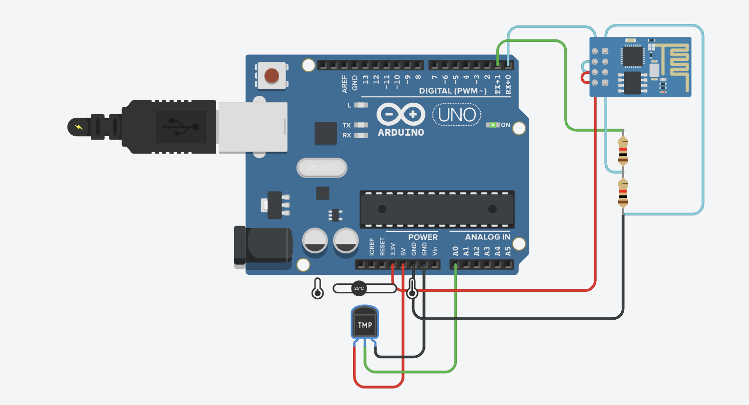

**Conclusion :**

This project successfully stores real-time sensor data in Firebase using Arduino and NodeMCU. It introduces the concept of cloud storage and real-time database management, forming a critical step toward developing smart IoT systems for data logging and remote access applications.